SARA MOUNTJOY-PEPKA
SAG/EMC
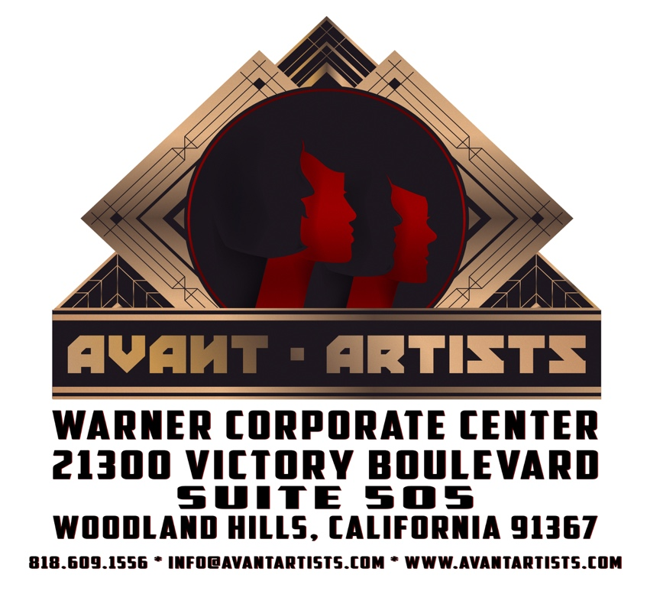
Height: 5’9” – Weight: 132 lbs
Avant Artists: 818.609.1556, Maggie@AvantArtists.com
SaraMountjoyPepka.com, sara.mountjoy.pepka@gmail.com, 253.224.0811

FILM
The Tempest | Antonio (Lead) | Timothy Welch
The Hunt (Pilot) | Lead | Hardly Working Entertainment
Cheetah | Lead | Int’l Academy of Film and Television
Standardized Patients (Pilot) | Supporting | Orange Vest
The Coffee Table | Supporting | Scotto Moore
TELEVISION
Q13 This Morning | NERDProv (Short-form improv) | FOX
COMMERCIAL/INDUSTRIAL/PRINT – Conflicts available on request.
THEATER (Selected)
Much Ado About Nothing | Hero | Dir. Joel Jahnke, Montana Shakespeare…Parks
The Merchant of Venice | Narissa | Montana Shakespeare in the Parks
Anna Karenina | Kitty Scherbatsky | Book-It Repertory Theatre
The Trial* | Eva | Dir. John Langs, New Century Theatre Co.
Into the Woods | Cinderella’s Stepmother | Mt. Baker Repertory Theatre
Romeo and Juliet | Lady Capulet | GreenStage Shakespeare in the Parks
Crash* | Abby/Jane/Mom** u/s | Dir. Rita Giomi, Seattle Children’s Theatre
The Winter’s Tale | Dorcas | Seattle Shakespeare Company
*World Premiere ** Performed Role
IMPROV (Selected)
Dorothy Parker UnScripted | Long-form improv | Impro Theatre – Main Company
Horror UnScripted | Long-form improv | Impro Theatre – Main Company
Star Trek: The Improvised Generation | Long-form improv | Impro Studio Presents
Chekhov Improvised | Long-form improv | Impro LAB (Masterclass)
Twilight Zone Improvised | Long-form improv | Impro LAB (Masterclass)
Jane Austen Improvised | Long-form improv | Impro LAB (Masterclass)
INTERNET
Bearded Men “Dungeons and Dragons” | Long-form improv | Geek & Sundry / Twitch
Ripley Improv Presents “Dystopia” | Long-form improv | HyperRPG / Twitch
The Gauntlet | Long-form improv | HyperRPG / Twitch
TRAINING
Anthony Meindl Acting Workshop | Scene Study - MASTERCLASS
Lesly Kahn @ Lesly Kahn Inc. | Scene Study
Alyson Horn / Ross Lacy Casting | Commercial
Camera Left / Stage Right | Commercial
Impro Theatre | Improv – Impro LAB
The Groundlings | Improv
Voice Trax West | Voice Over
Freehold Theatre | Shakespeare/Clown
Magic Circle Mime | Mime
Cornish College of the Arts | Musical Theatre
SPECIAL SKILLS
I majored in bassoon, and am a professional mime and long-time improviser. A massive Trekkie and geek. Pretty fine at whistling.

